Practical No 08
VIII. Resources required (Additional)
→ If any web resources required.

Resources used (Additional)
→ https://docs.microsoft.com/en- us/dotnet/api/system.windows.forms.textbox?view=netframework-4.7.2
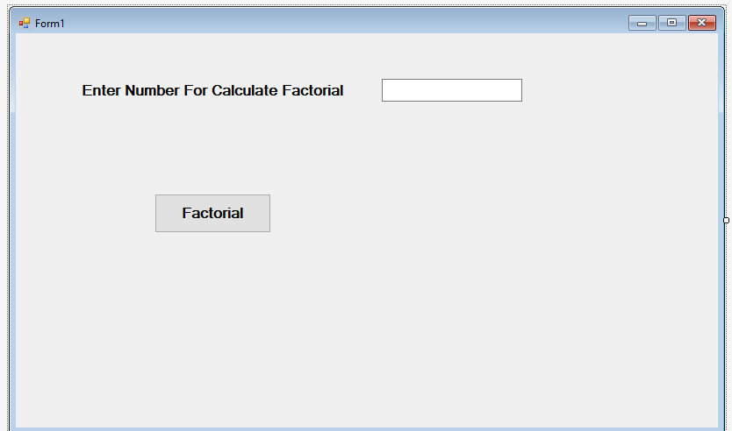→ https://docs.microsoft.com/en- us/dotnet/api/system.windows.forms.label?view=netframework-4.7.2
→ https://docs.microsoft.com/en- us/dotnet/api/system.windows.forms.button?view=netframework-4.7.2

Program Code
Write a program to demonstrate the use of Button, Textbox and Label.

Public Class Form1
Private Function Factorial(ByVal num As Integer) As Long Dim fact As Long = 1
Dim i As Integer

For i = 1 To num fact *= i
Next
Factorial = fact End Function
Private Sub Button1_Click(sender As Object, e As EventArgs) Handles Button1.Click Dim fact As Long
fact = Factorial(TextBox1.Text)
MessageBox.Show("Factorial of " & TextBox1.Text &
" is " & fact, "Factorial", MessageBoxButtons.OK, MessageBoxIcon.Information)
End Sub End Class

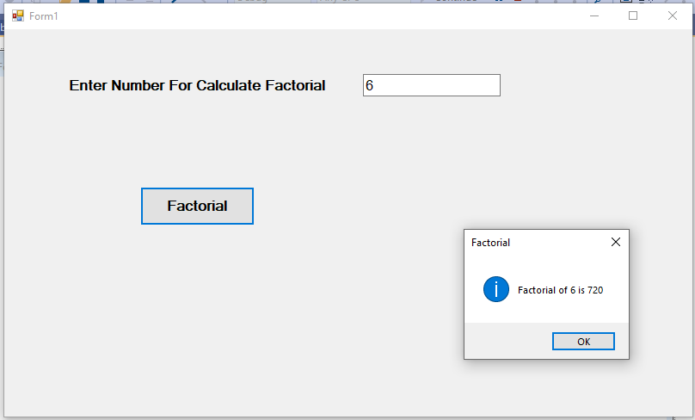Results (output of the program)

- Practical related Questions
  - Write the use of Tab Index property of the control.
- The following example uses the TabIndex property to display and set the tab order for individual controls. The user can press Tab to reach the next control in the tab order and to display the TabIndex of that control.

Write the code to generate button at runtime in VB.Net.
- 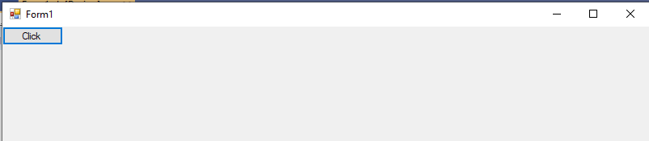Public Class Form1
Private Sub Form1_Load(sender As Object, e As EventArgs) Handles MyBase.Load Dim b As New Button
b.Text = "Click" Me.Controls.Add(b)
End Sub End Class

Output:

- rcise
  - Write a program to perform the arithmetic operations using controls Label, Button and TextBox.
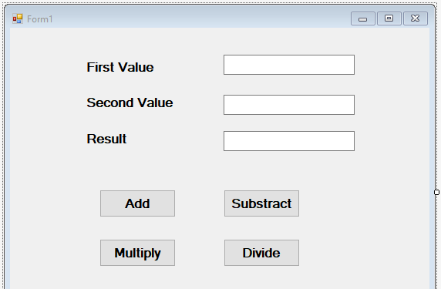➢

Public Class Form1 Dim n As Integer
Private Sub Button1_Click(sender As Object, e As EventArgs) Handles Button1.Click n = Val(TextBox1.Text) + Val(TextBox2.Text)
TextBox3.Text = n End Sub

Private Sub Button2_Click(sender As Object, e As EventArgs) Handles Button2.Click n = Val(TextBox1.Text) - Val(TextBox2.Text)
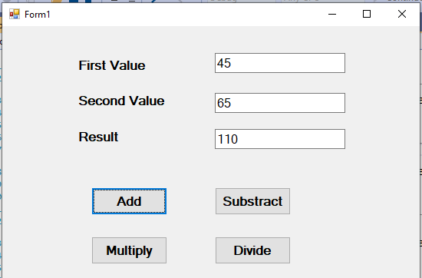TextBox3.Text = n End Sub

Private Sub Button3_Click(sender As Object, e As EventArgs) Handles Button3.Click n = Val(TextBox1.Text) * Val(TextBox2.Text)
TextBox3.Text = n End Sub

Private Sub Button4_Click(sender As Object, e As EventArgs) Handles Button4.Click n = Val(TextBox1.Text) / Val(TextBox2.Text)
TextBox3.Text = n End Sub
End Class

Output:

  - Write a program to change the background color of the form when user clicks on different buttons.
➢

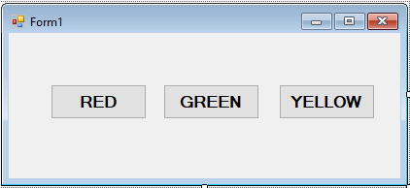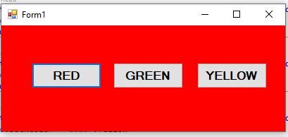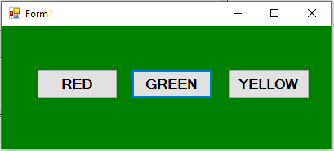
Public Class Form1
Private Sub Button1_Click(sender As Object, e As EventArgs) Handles Button1.Click Me.BackColor = Color.Red
End Sub

Private Sub Button2_Click(sender As Object, e As EventArgs) Handles Button2.Click Me.BackColor = Color.Green
End Sub

Private Sub Button3_Click(sender As Object, e As EventArgs) Handles Button3.Click Me.BackColor = Color.Yellow
End Sub End Class
Output:

